**Level 1 Eliza**

1. Research the “ELIZA Computer Therapist Program”. Summarize your answers to the following:
   1. What does the program do?

A natural language Ai based computer program. Like any bot/chatbot it is a software that automates a certain task for users. More importantly, a computer program that mimics a Rogerian psychotherapist.

* 1. When and why was the program created?

The program was created by a professor named Joseph Weizenbaum who developed it to demonstrate the uniqueness of communication between humans and machines in 1966. ELIZA is considered to be the first chatterbot in the history of computer science.

* 1. How does the program work?

It responds to your comments with generic statements like “Tell me more...” to keep the user engaged in using the program. It will also reinstate some keywords of the users inputted statements to keep questions flowing that relate to what is being discussed.

1. Use an online version of the ELIZA program to see what it is like.
   1. Open the URL : <http://psych.fullerton.edu/mbirnbaum/psych101/Eliza.htm>
   2. Begin by talking about your feelings (just like if you were talking to a guidance counselor).
   3. After a while, try to trick the program.
2. In what ways did the program seem like you were talking to a real person? What was a strategy used by the program to keep the discussion going? It will at times reuse some keywords of the users inputted statements to keep questions flowing that relate to what is being discussed.
3. In what ways could you tell that it was not a real person? What were some of the weaknesses of the program?

The way Eliza would repeat the same line in response if the user inputted the exact same message over and over again.

1. If you had your friend talk to ELIZA but did not tell them it was a program, how long do you think it would take for them to figure it out? Explain your answer.

Probably in a few minutes as a lot of the statements are generically outputted like any old AI that is not capable to compute a lot of variation in its outputs. As even at the time there was not a lot of technical resources and huge development to have a higher possibility of varied outputs that the program could produce. So I think it would be fairly obvious to figure out as opposed to chat bots much newer and complex that can be found on a lot of third party torrenting websites and even dating websites where they know how to draw in the user because of the innovation in how today’s AI bots can be programmed.

**Level 2 Turing Test**

1. Research the “Turing Test”. Summarize your answers to the following:
   1. What is the Turing Test?

A test developed by Alan Turing in 1950, in which is to testify a machine's ability to have intelligent behaviors or determine if it is inferior in comparison to a human being. When leaning towards a more artificial intelligence (AI) perspective, this is simply a method for determining whether or not a computer is capable of thinking like a human being.

* 1. Who was Alan Turing?

During World War 2, the industries of early technology saw a new era with people like Alan Turing who are pioneers for their code-breaking efforts during the mid-20th century. Turing is most credited for solving a telecommunication system known as the Enigma that was related to code breaking the Nazis.

* 1. How does the Turing Test work?

It was carried out like an imitation game as one side of a computer screen had a human judge, whose job is to chat to some mysterious interlocutors on the other side. Most of those interlocutors will be humans; one will be a chatbot, created for the sole purpose of tricking the judge into thinking that it is the real human.

The imitation game (test) had three participants: a man, a woman, and an interrogator. The interrogator is in a separate room and has to determine which of the participants is the man and which one is the woman. The interrogator can ask questions and the objective of person A is to try and confuse the interrogator while person B is allowed to provide answers that would help the interrogator.

The answers are sent to the interrogator via a teleprinting machine.

Turing’s version of the game would replace person A with a machine while the role of person B is still performed by a woman. If the machine could convince the interrogator that it’s a woman, it would pass the test.

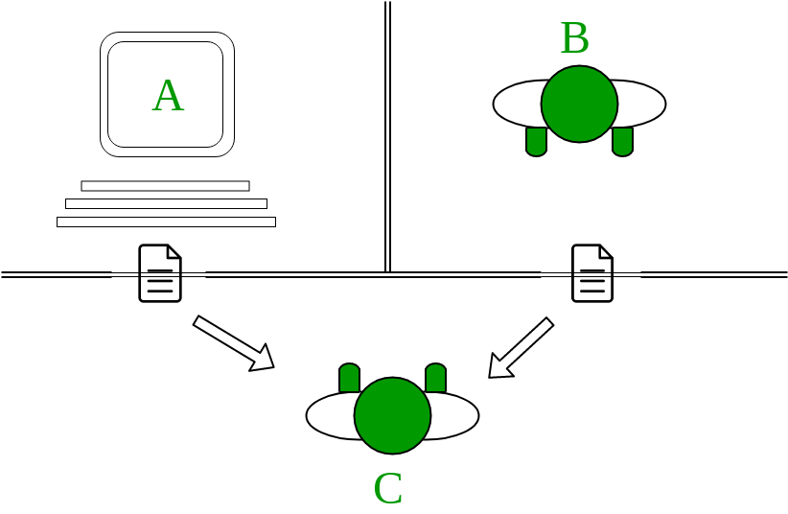

Computer (A) and a human (B) are on one side and a human tester (C) on the other side. If the tester (C) can't recognize which candidate is human and which candidate is a computer after a series of questions, then the computer successfully passed the Turing test.

Tester (C) is not allowed to see the contestants so they can't make the decision based on their physical appearance.

* 1. How is the Turing Test different from other Artificial Intelligence tests?

Other Ai verification systems such as Google’s reCAPTCHA which is found on many websites and applications today are done on a more software functionality platform of build and development. Where the program is automatically prompted to verify whether or not a user is a bot or human.

1. Visit the Ted Ed website to learn more about the Turing Test.
   1. Watch the video at: <https://ed.ted.com/lessons/the-turing-test-can-a-computer-pass-for-a-human-alex-gendler>
   2. Complete the online test at: <https://ed.ted.com/lessons/the-turing-test-can-a-computer-pass-for-a-human-alex-gendler#review>
2. Has any computer AI passed the Turing Test? Research this question and report on your results.

A computer AI that simulated s a 13-year-old Ukrainian boy called Eugene Goostman was the first in 2014 to pass the Turing test.

1. Do you think that you have ever been fooled by an on-line computer AI program? Explain your answer.

Yes, back when I thought free gift cards and rewards online was a thing. As I went on a few sites that claimed to offer free Playstation dollars if you sign up for accounts which were prompted by the websites bot. The bot would fraudulently claim that it is scanning/verifying that the sign up with the third party website is fulfilled so that it can reward the user with an item but it never happened and I wasted hours thinking it was trial and error with me and my computer system. Although in reality it was designed to just waste people's time and gain ad revenue for visits on these websites.

**Level 3 Article reviews**

Pick any three (3) out of the following four (4) articles to read and review. Answer the questions that are specific to each article.

**Article 1: Social Media Bots**

Read the following article:

https://www.questia.com/magazine/1G1-530914703/social-media-bots-how-they-spread-misinformation

1. How much internet traffic is estimated to be produced by AI bots?

30% of internet traffic is produced by bots.

1. What are some strategies used by bots to appear more human?

Some social bots were developed to behave like a human using emojis in their posts and only posting at daytime hours of the day or limiting the amount of information they share. They have become in some ways sophisticated, making it difficult to determine a bot from a human.

1. How many social media accounts are estimated to be AI bots?

Twitter revealed approximately 8.5% of all its users were bots, and that number may have increased to as much as 15% in 2017.

1. How easy is it for a user to detect that they have been “friended” buy a social media AI bot?

Users who are unaware that they are interacting with a bot can easily be fooled with false information as more than 20% of real Facebook users accept friend requests. Additionally, people with a large number of friends are more likely to accept requests from people they don't know. This can make it relatively easy for bots to take advantage social media users.

**Article 2: Social Media Bots**

Read the following article:

https://www.usnews.com/news/healthiest-communities/articles/2018-07-24/how-social-media-bots-could-compromise-public-health

1. How many social media accounts are estimated to be AI bots?

Researchers estimate that there are tens of millions of bots which are automated accounts posed as real people.

1. What is the purpose / objective of these AI bots?

They can be used to spread misleading or false information to possibly increase their follower counts.

1. How could a bot be used to increase the number of people vaping or smoking?

Bots could push deceptive messages and generated post on promoting cigarettes to make it seem like those behaviors or products are more popular than they actually are. That could promote poor or misinformed health decisions. They post hashtags about smoking like for example, when the bots promote vaping as a safe alternative to traditional tobacco cigarettes.

1. How could a bot be used to increase the public concern about getting vaccinated?

The bots generate millions of messages portraying vaccinations as harmful through the false comments of opinions made on other user’s post and their generated post.

1. What is a “sockpuppet”?

A fake or deceptive account managed by a real person in which is more referred to as a troll account. Which are created for the purpose of angering, annoying and distracting other users in some way.

**Article 4: Automated Journalism**

Read the following article:

https://digiday.com/media/washington-posts-robot-reporter-published-500-articles-last-year/

1. What is the name of the Washington Post’s robo-journalist and what was its first assignment?

Heliograf and his first assignment was to output around 300 short reports and alerts on the Rio Olympics.

1. How can robo-reporting expand the audience for newspapers?

The Post has produced around 850 articles using Heliograf. That included 500 articles around the election that generated more than 500,000 clicks

1. How can robo-reporting help human journalists?

During the election, Heliograf was used to alert the newsroom when election results started trending in an unexpected direction, giving reporters lead time to thoroughly cover the news. Some see Heliograf to play a more roles in the next election. Also potential for Heliograf to spot the latest trends.

1. Are smaller news organizations using robo-reporting? What are the benefits to smaller organizations?

It can serve a lot for niche audiences, which can increase a news outlet’s clicks. Heliograf can be used for data like standardized test scores and crime stats.

1. Do you think this article was written by a robo-reporter? Explain your answer by giving examples of both why and why not.

A lot of computer generated and automated content today can be hard to tell apart if it was produced by human or a computer system. More so, with the way a lot of big news outlets find it much more efficient and better for business to have more articles written and released. There is no doubt that many articles that could be read online, possibly including this specific one could have been written using an AI. However, there is a possibility of this being incorrect as the article is claimed to be written by a journalist named Lucia Moses on September 14, 2017.